**ELECTIVE 3: FULLSTACK WEB DEVELOPMENT**

**PRELIMINARY EXAMINATION**

**2nd Semester, Academic Year 2020-2021**

Please follow the directions for each section. Note that in each section you will have some amount of choice in the questions you’ll be answering. The exam is based on a 100-point scale. Partial credit will be given for answers that are done partially well.

**Programming** (50 points ).

1. Requirements:
   * 1. Copy and download source of this website blog layout shown here : <https://getbootstrap.com/docs/5.0/examples/blog/#>
     2. Here is the source of codes in HTML: <https://getbootstrap.com/docs/5.0/examples/>
2. Create the below
   1. Follow layout below, create project file in Github with the following naming convention, E3ME_LASTNAME_FIRSTNAME (upper case)
   2. Fonts can be altered and changed
   3. DATA IS NOT NEEDED - for now. Let’s make this static.

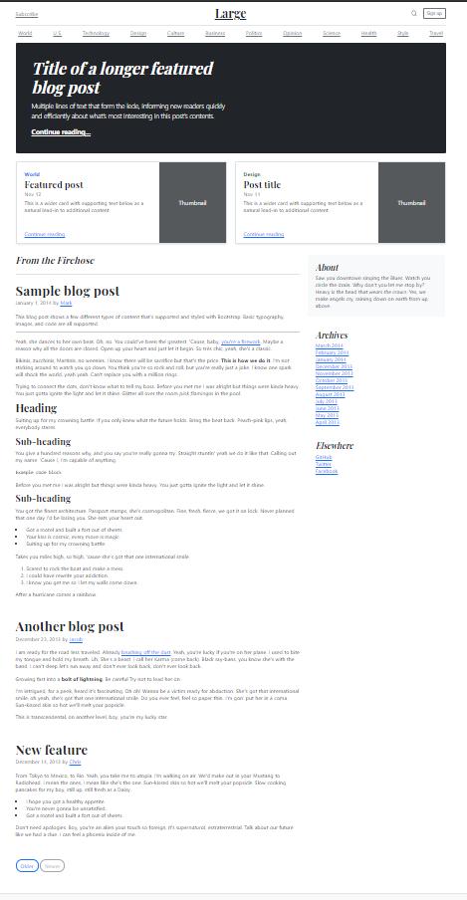

**Essay** (25 points):

1. Create a sample code snippet that demonstrates passing a callback function from a parent component down to its child(ren) component.
2. Explain props-drilling.

|  |  |  |
| --- | --- | --- |
| Prepared By:  NINO FRANCISCO ALAMO  Professor /Instructor | Reviewed By:  REGIE ELLANA  CCS Dean | Approved By:  DR. LEAH DIGO  VP for Academic Affairs |

|  |
| --- |
| **LOA-OAA-TOS-028** |
| **10-02-2020 | REV. 00** |

|  |  |
| --- | --- |
| **CODE** | **ELEC323** |
| **TITLE** | **ELECTIVE 3: FULLSTACK DEVELOPMENT** |
| **EXAM** | **PRELIMINARY EXAMINATION** |
| **TERM/AY** | **2ND SEMESTER, ACADEMIC YEAR 2020-2021** |

|  |  |  |  |  |  |  |  |  |
| --- | --- | --- | --- | --- | --- | --- | --- | --- |
| **Topic #** | **Objectives** | **Remember** | **Understand** | **Apply** | **Analyze** | **Evaluate** | **Create** | **Total # of Items/points** |
| 1 | * To apply the concepts of MVC   + - * + Creating Views         + Persisting to Database | 2 | 2 | 2 | 1 | 1 | 2 | **10** |
| **Total # of items/Points** | | 2 | 2 | 2 | 1 | 1 | **2** | **10** |

|  |  |  |
| --- | --- | --- |
| Prepared By:  NINO FRANCISCO ALAMO  Professor /Instructor | Reviewed By:  REGIE ELLANA  CCS Dean | Approved By:  DR. LEAH DIGO  VP for Academic Affairs |